**Junit testing exercises**

**Exercise 1: Setting Up Junit**

Create a Test Class

Simple.test

package com.example.test;

import org.junit.Test;

import static org.junit.Assert.*;

public class SimpleTest {

@Test

public void testAddition() {

int result = 2 + 3;

assertEquals("Sum should be 5", 5, result);

}

}

**Output:-**

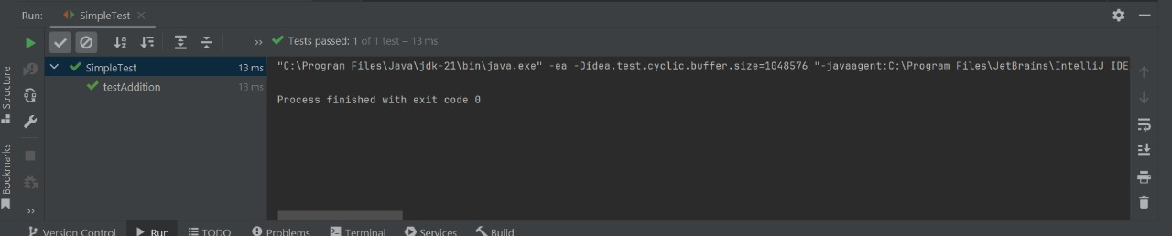

**Exercise 3: Assertions in Junit**

AssertionTest.java

import org.junit.Test;

import static org.junit.Assert.*;

public class AssertionsTest {

@Test

public void testAssertions() {

// Assert equals

assertEquals("Sum should be 5", 5, 2 + 3);

// Assert true

assertTrue("5 is greater than 3", 5 > 3);

// Assert false

assertFalse("5 is not less than 3", 5 < 3);

// Assert null

assertNull("Object should be null", null);

// Assert not null

assertNotNull("Object should not be null", new Object());

}

}

**Output:-**

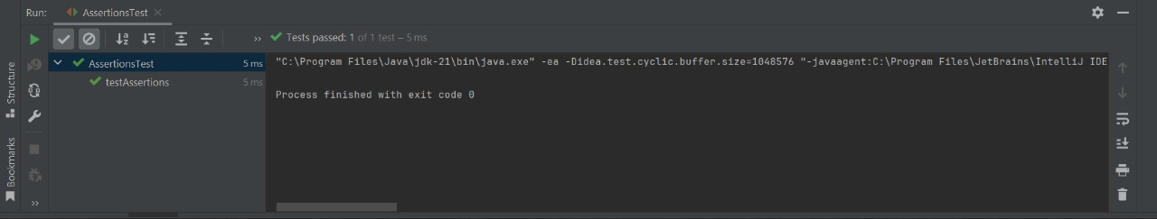

**Exercise 4: Arrange-Act-Assert (AAA) Pattern, Test Fixtures, Setup and Teardown Methods in Junit**

Calculator.java

public class Calculator {

public int add(int a, int b) {

return a + b;

}

public int subtract(int a, int b) {

return a - b;

}

}

CalculatorTest.java

import org.junit.After;

import org.junit.Before;

import org.junit.Test;

import static org.junit.Assert.*;

public class CalculatorTest {

private Calculator calculator;

// Setup method

@Before

public void setUp() {

calculator = new Calculator(); // Arrange

System.out.println("Setup completed.");

}

// Teardown method

@After

public void tearDown() {

calculator = null;

System.out.println("Teardown completed.");

}

@Test

public void testAddition() {

// Act

int result = calculator.add(10, 5);

// Assert

assertEquals("10 + 5 should be 15", 15, result);

}

@Test

public void testSubtraction() {

// Act

int result = calculator.subtract(10, 5);

// Assert

assertEquals("10 - 5 should be 5", 5, result);

}

}

**Output:-**

